ECLIPSE INSTALLATION GUIDE

1. Download the Eclipse software

* Go the browser and search eclipse ide for java developers
* link : <https://www.eclipse.org/downloads/packages/release/oxygen/3a/eclipse-ide-java-developers>
* Then choose the Older stable version because later version have plugin issues

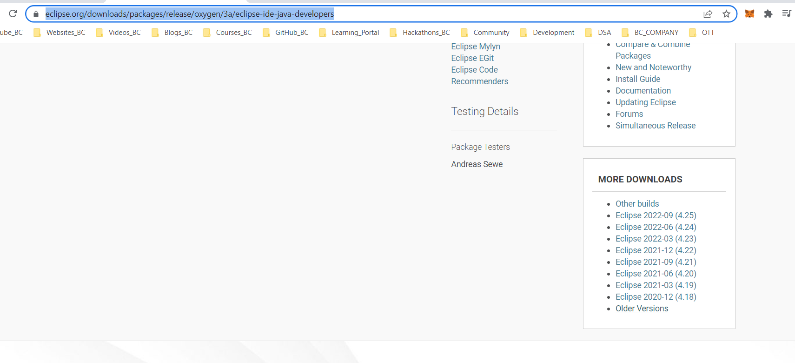

* Choose the 2020-06 stable version and click on R packages

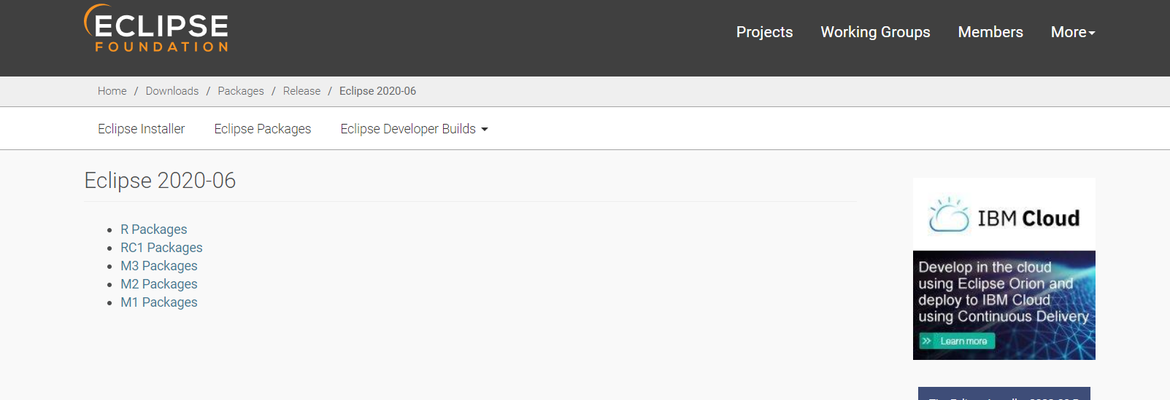

* And choose Eclipse IDE for Enterprise Java Developers -> windows x86_64

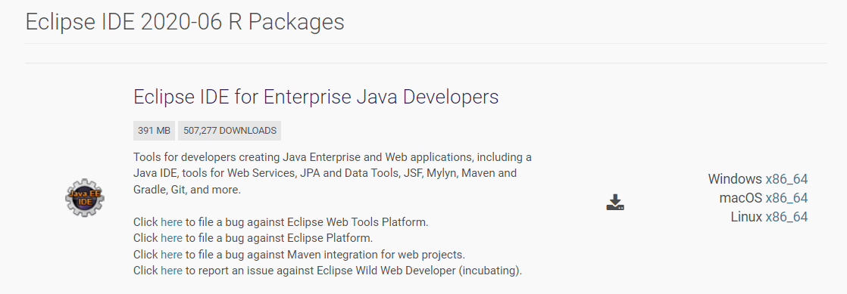

1. For windows user copy the zip file and store in the D: drive and extract it.

* Open the eclipse folder and run the eclipse application

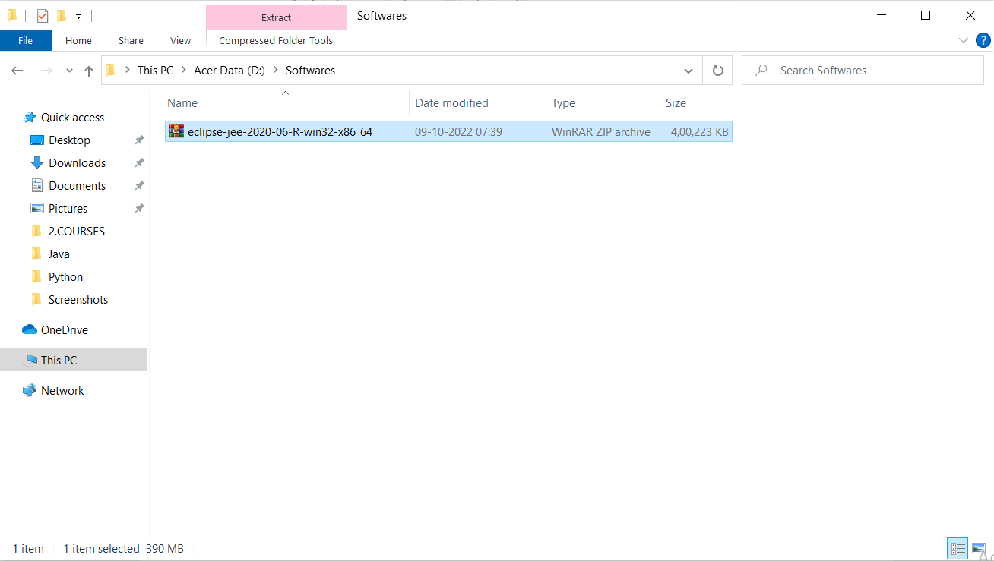

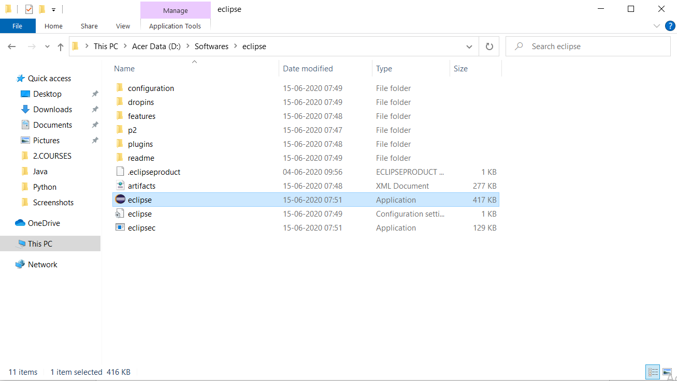

* Choose the work space that is create a new folder and choose the that path and don’t checkmark it and launch.

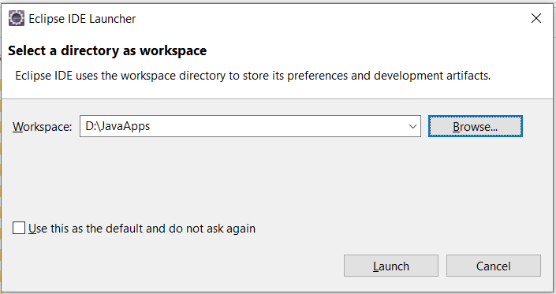

1. Now it launches the IDE and start working on it

* Close the welcome page

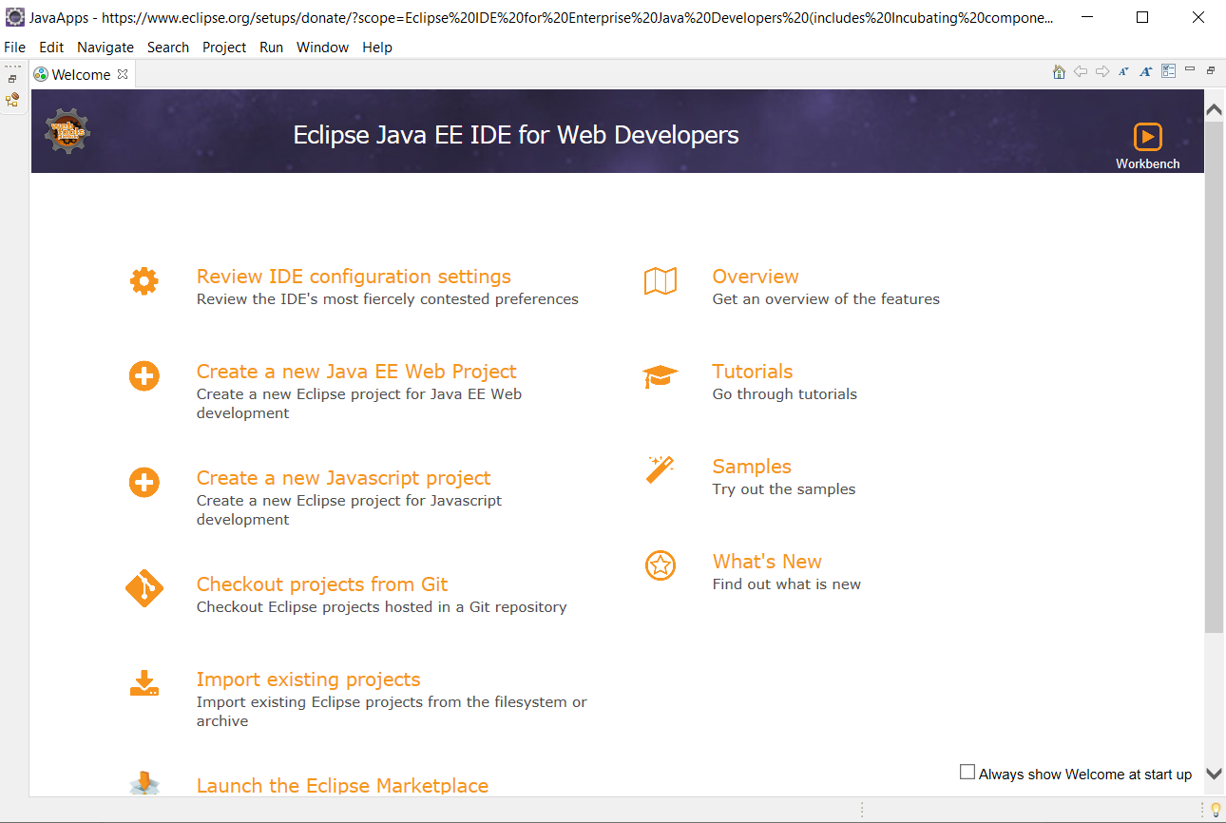

* By default the perspective is web development now change this to java by click on the open perspective on top right corner
* It will changes the java plugin and close all the unnecessary tabs

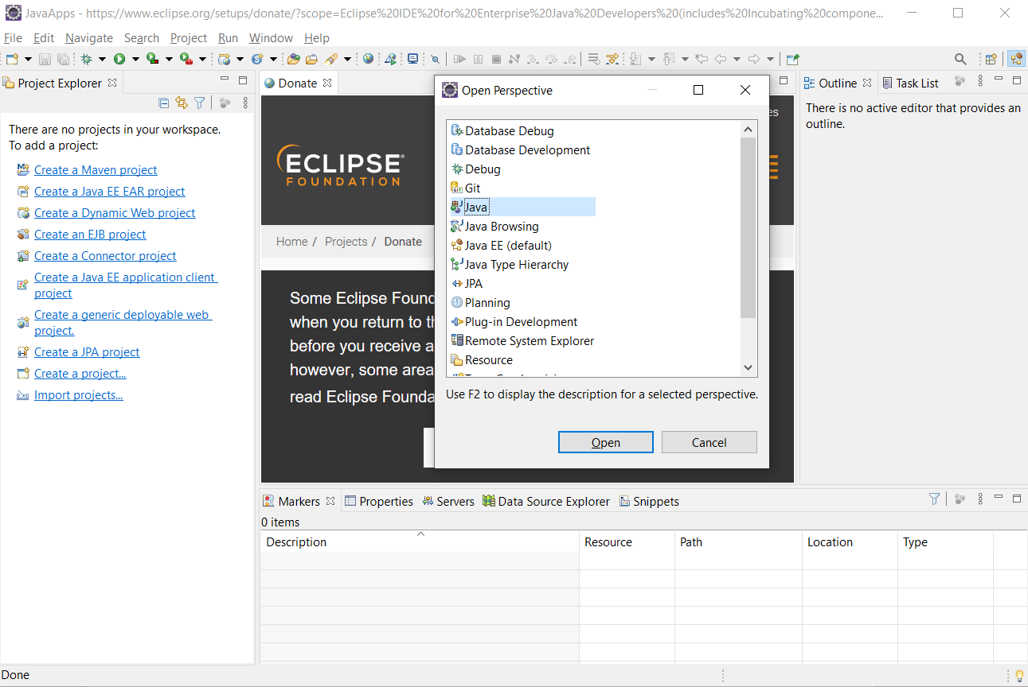

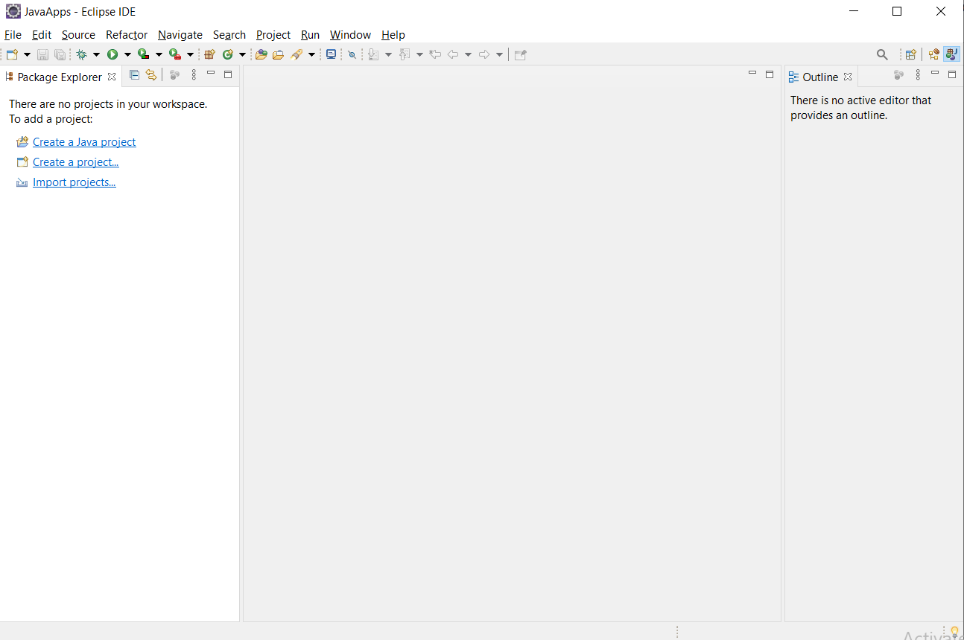

1. Start your first Java project

* Click on create java project and enter the project name by default eclipse taken the JDK-14 standard one to execute the java programs by we can configure it

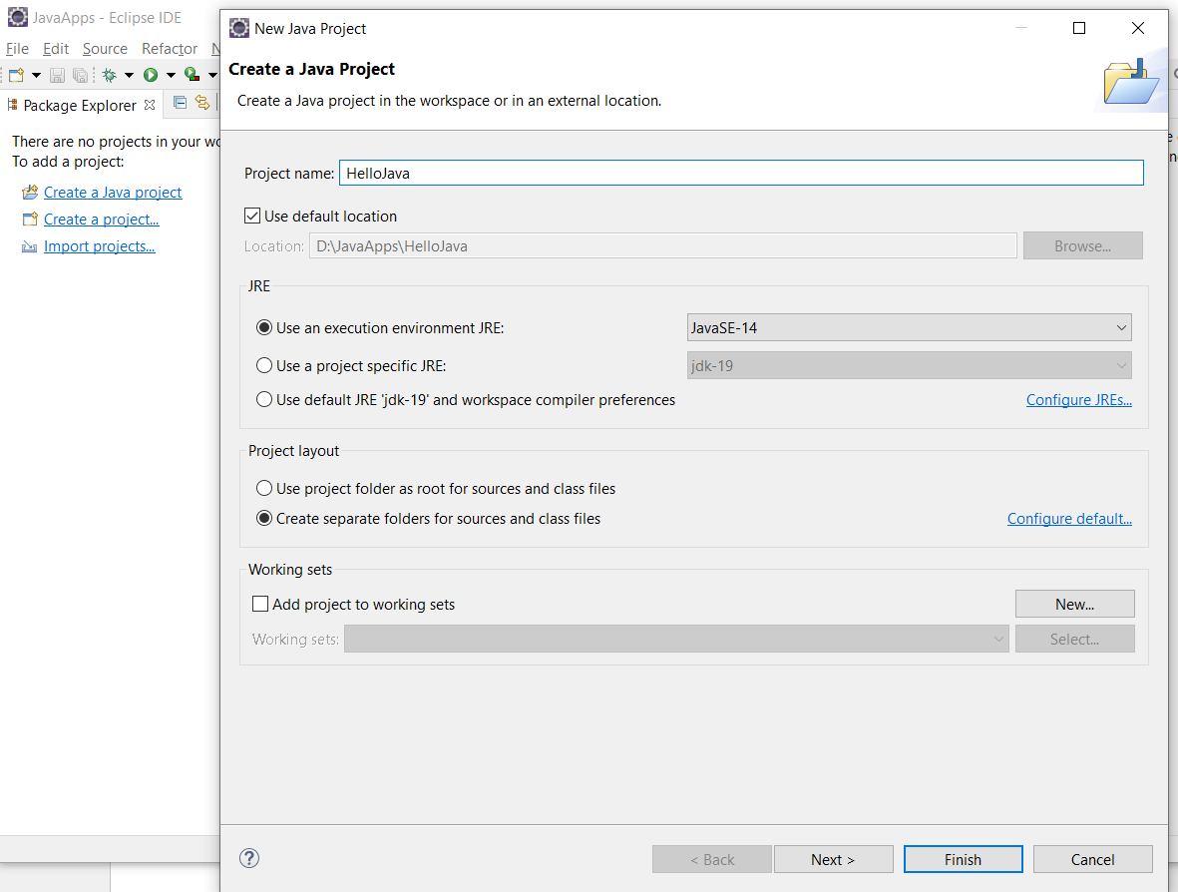

* Create new class in the source folder and write your first program

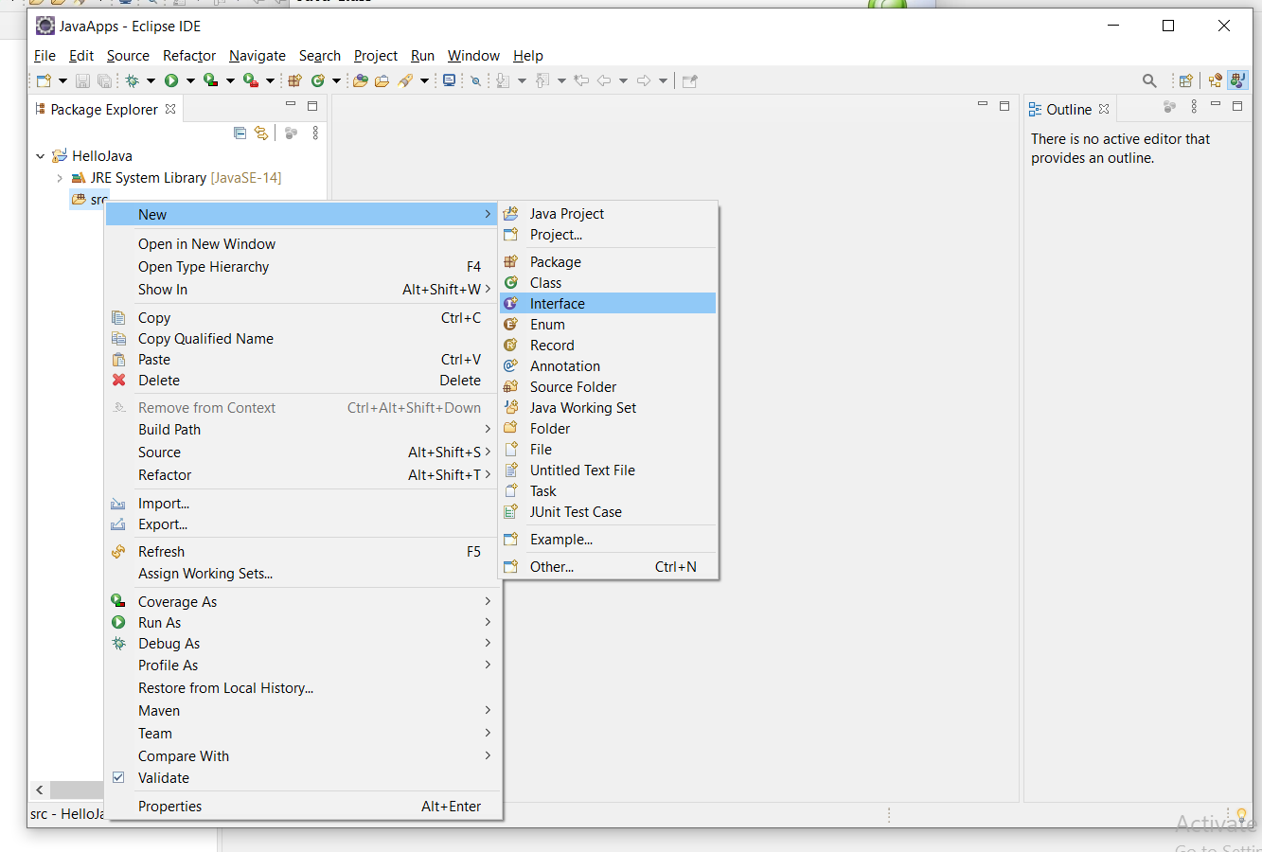

* Write the package name and class name and tick mark on the public static void main and the finish

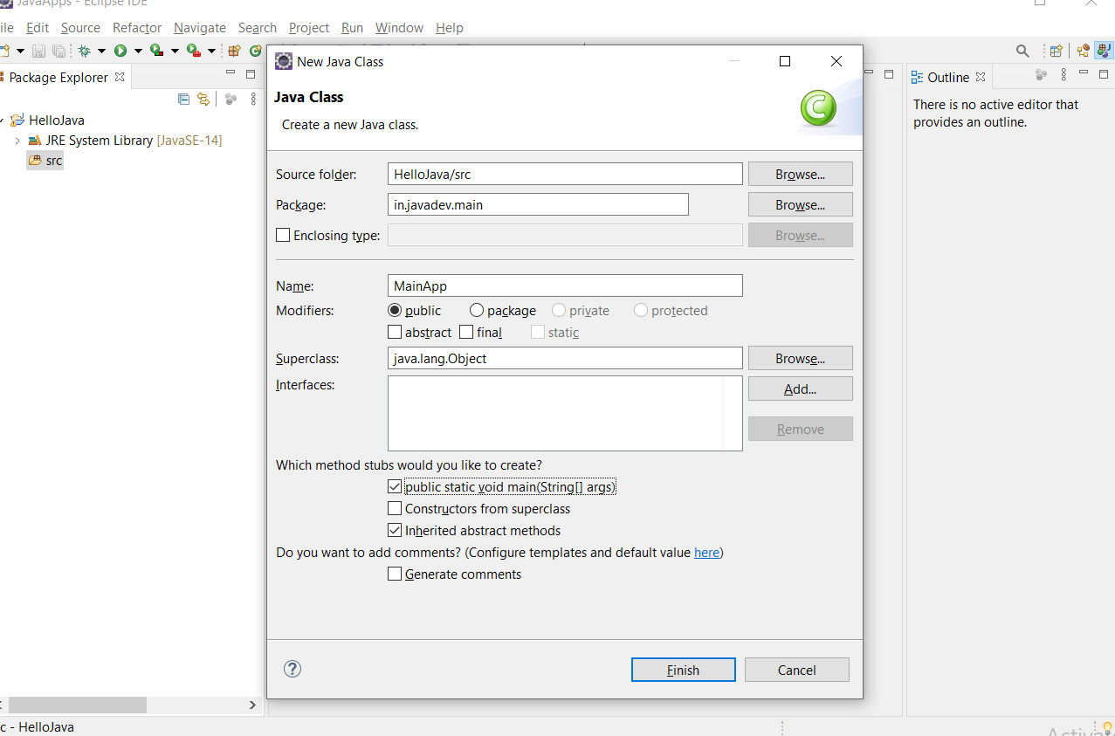

* Write your first line of code and then execute it and it was executed using the JDK-19 it was installed in the system

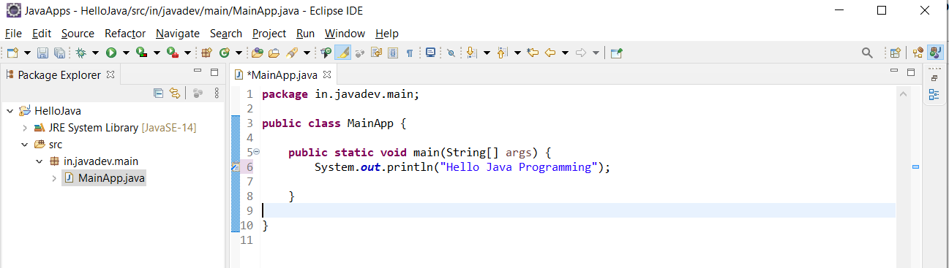

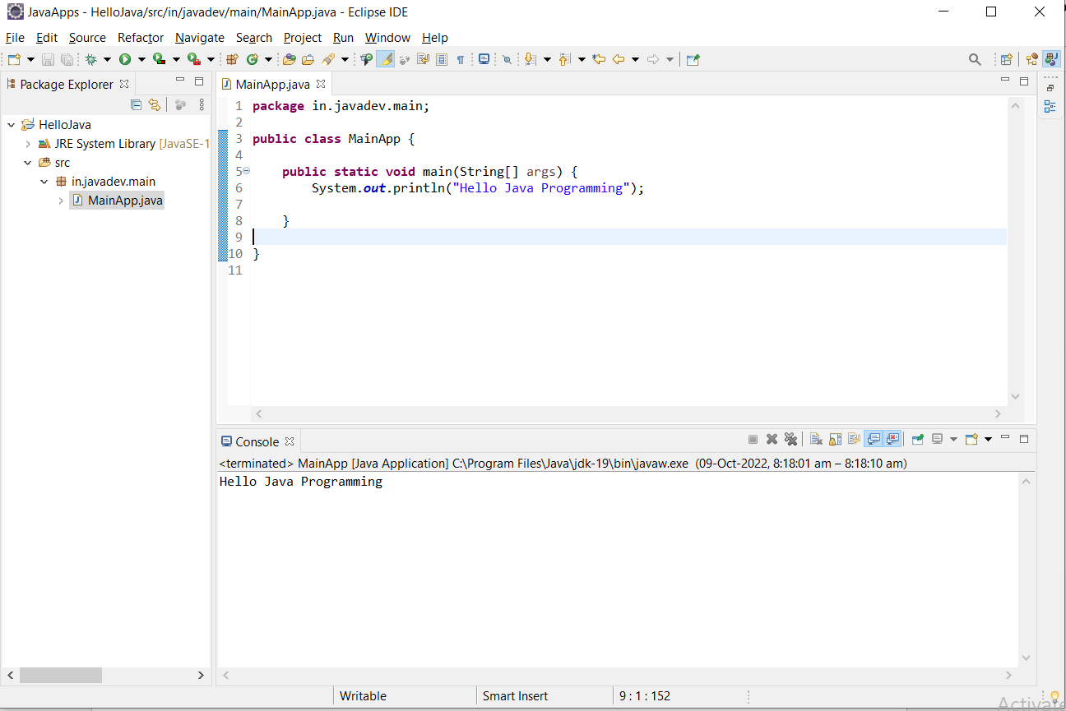

1. Change the JDK version

